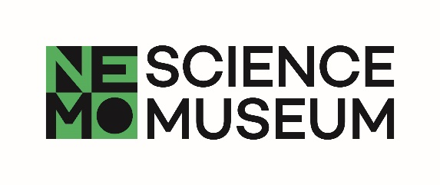

**SCIENCE LIVE**

**Take part in science**

**Become a participant!**

**Title of study:** How good are you at lying and detecting lies?

**Head scientist(s):** Prof. Dr. Theo Gevers, Prof. dr. Albert Ali Salah

**Researchers:** Dr. Sezer Karaoglu, Dr. Sophie van der Zee, Dr. Ronald Poppe

**University / Department**:University of Amsterdam – Informatics Institute, Utrecht University - Department of Information and Computing Sciences, Erasmus University Rotterdam - Erasmus School of Economics

**Dear NEMO-visitor,**

Would you like to take part in a real science project? Come to **Science Live,** NEMO’s longstanding research program. **Science Live** is an ongoing project with real scientists, who come to NEMO because they need participants of different ages and backgrounds. This handout gives more information about the study that is now taking place at NEMO.

**Who is doing the research?**

The project is carried out by scientists at the University of Amsterdam, Utrecht University and Erasmus University Rotterdam.

**What is being studied in this research?**

“I'm on my way!” “I've read that book twice.” We all tell small lies. But do others believe us? We will investigate what makes a good liar, and how liars can be spotted. We would like to know how age and familiarity play are role. Also, we will teach computers to be better lie detectors by paying close attention to your behavior.

**What will happen during this experiment?**

In this experiment, you will be both liar and lie detector. You'll start with filling in a questionnaire so we can get to know you. We will use it to understand if some traits will help you in telling or spotting lies. Then it's your turn to describe something you've seen and something you haven't. With various cameras and microphones we will record every move and word. Then the tables are turned and we'll investigate how well you can spot lies by watching short clips of other participants. We'll also see if you can catch your family members red handed! We keep track of the best liar, but also who's our best lie detector.

No reward is given for participation. All research data remains confidential and is processed anonymously. The research data is disconnected from names; only the principal investigator has access to names. The regular liability insurance of the University of Amsterdam applies to this research.

**Who can take part in this study?**

Every visitor aged 8 and over is welcome to take part in this task/experiment/study.

**How can I take part?**

Go to the **Science Live** room and sign up with the researcher. They will ask you to fill in a consent form. Giving informed consent is standard practice for scientific research involving human participants.

**Are you younger than 18 years?**

Then bring your parent(s) with you to sign to the consent form. Your parents, brothers and sisters can join in the experiment!

Once you have given consent you can begin the experiment. The task takes about 15 minutes.

**Can I change my mind?**

Of course! You can stop the experiment at any time, without need for explanation. Just let the researcher know. If you do not want your data to be used afterwards, please inform Ronald Poppe by email within 24 hours of your participation in the study ([r.w.poppe@uu.nl](mailto:r.w.poppe@uu.nl)). Aborting the task will not affect you and your data will be deleted.

**Can I get more information about the study I took part in?**

When you have finished the experiment you will get a handout with more detailed information about the study. You will also have the opportunity to ask questions to the researchers.

**Where can I learn about the results of the study?**

Would you like to find out about the results of the study? Note this on the consent form. The results are expected to be available around September 1st. You can also keep an eye on [www.nemosciencemuseum.nl/sciencelive](http://www.nemosciencemuseum.nl/sciencelive).

**Who can I contact if I want to find out more about this research project?**

If you have questions about this research project you can contact the lead researcher, Ronald Poppe via email (r.w.poppe@uu.nl). For any potential complaints about this research you can contact the member of the Ethics Committee of the Erasmus Research Institute of Management: Bálint Hardy, Burgemeester Oudlaan 50, 3062 PA, Rotterdam, [hardy@rsm.nl](mailto:hardy@rsm.nl\), +31104089076.

**Who do I contact if I have questions about NEMO’s Science Live?**

If you have questions or comments about **Science Live,** or if you want to know about future **Science Live** projects, please contact NEMO Science Museum via [sciencelive@e-nemo.nl](mailto:sciencelive@e-nemo.nl).